About Google's SafeSearch filter
Many users prefer not to have adult content included in their search results (especially if kids use the same computer). Google's SafeSearch filters provide you with the ability to change your browser setting to prevent adult content from appearing in your search results. Google uses automated methods to identify objectionable content, and constantly works to improve those methods based on user feedback. For sexually explicit content, our filter mainly relies on algorithms that look at many factors, including keywords, links, and images. No filter is 100 percent accurate, but SafeSearch should help you avoid most of this type of material.

Enable the SafeSearch filter
- Visit the Google Preferences page.
- In the SafeSearch Filtering section, choose the SafeSearch level you'd like to use:
  - Strict filtering filters sexually explicit video and images from Google Search result pages, as well as results that might link to explicit content.
  - Moderate filtering excludes sexually explicit video and images from Google Search result pages, but does not filter results that might link to explicit content. This is the default SafeSearch setting.
  - No filtering, as you've probably figured out, turns off SafeSearch filtering completely.
- Click Save Preferences at the bottom of the page when you're done setting your preferences.
We do our best to keep SafeSearch as up-to-date and comprehensive as possible, but objectionable content sometimes slips through the cracks. If you have SafeSearch set to Strict and still stumble upon search results containing explicit content, please visit our webpage removal request tool to tell us about the sites or images you found.
Also, please note that no filter can replace a watchful eye. SafeSearch can serve as one of many tools and practices to help your family search the web more safely. For more pointers on keeping your family safe on the web, visit Google's Family Safety Center.
SafeSearch should remain set as long as cookies are enabled on your computer, although your SafeSearch settings may be reset if you delete your cookies.
Learn more
Firewalls, proxies, and anti-virus programs are often configured to periodically delete cookies. If you access Google from behind one of these programs, you may have to reset your preferences periodically.
Your internet service provider (ISP) or network administrator can override your SafeSearch setting. If you find that your setting is not reflected in the search results you see, please contact your ISP or network administrator for more information.

Locking SafeSearch
The SafeSearch setting you select on the Search settings page applies to anyone using the same Web browser and computer as you. If you have a Google Account, you can lock the setting so that other users of the computer don't change it.

You can tell at a glance if the lock is engaged
When the SafeSearch lock is on, the top of the search results page looks different in two ways: 'SafeSearch is locked' is displayed below the search box, and the colored balls appear on the right. The results page is designed to look different enough that you can immediately tell whether the lock is on or off -- even from across the room.
Results page when locked
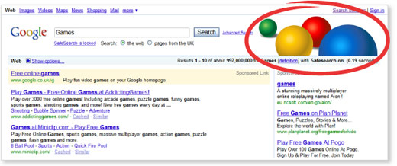

Follow these steps to lock SafeSearch:
- Visit the Search settings page.
- Click Lock SafeSearch below the filter levels.
- If you're not signed in to your Google Account, you'll be prompted to sign in. (Don't have a Google Account? You can create one.)
- Once you're signed in, click Lock SafeSearch. This step takes a moment, because strict filtering is being applied to all Google domains.
- You'll see a confirmation page once the lock is engaged.
Tips about browsers and settings
- If you have more than one browser on your computer, you need to set the lock on each one individually.
- If your computer has more than one user profile (for example, a family computer), you need to set the lock on each appropriate profile.
- Make sure your browser is set to allow cookies.
Using Safari? You may need to change the default setting and enable third-party cookies for the lock to work.

Unlocking SafeSearch
Return to the Search settings page and click unlock. (You'll need to sign in to the Google Account that was used to lock SafeSearch.)

